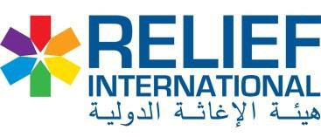

Annex A (ECHO - WASH NFIs) for ND

# | Item Description | Unit | QTY | Unit Cost SDG | Total cost SDG
1 | Multipurpose soap 180g with good quality, Make Bazar, | Caartons | 40
2 | Plastic bucket, with metallic handle and plastic lid. | Pcs | 160
3 | Jerri can plastic with RI & ECHO logo 20 liter | Pcs | 160
4 | Plastic basin middle size good quality, | Pcs | 160
5 | Plastic latrine mug good quality 1.5 Liter | Pcs | 160
6 | Toothbrushes, make TARA, for Adults (Soft & Hard) | Pcs | 320
7 | Toothbrushes, Child special | Pcs | 320
8 | Toothpaste, medium size for Adult | Pcs | 320
9 | Toothpaste children, medium size | Pcs | 320
10 | 1 Pairs of cotton underpants for women/adolescent girls | Pcs | 320
11 | 3 Pieces of re-usable sanitary cloth for women/adolescent girls | Pcs | 320
12 | 1 torch light Handheld torch, LED bulbs, self-powered | Pcs | 160
Total cost : |  | SDG

